TABLE OF CONTENTS For FACT OR FICTION RESEARCH PROJECT

Details of the Project……………………………………………………………….. Pages 2-4
Preapproval Form…………………………………………………………………….Page 5
Pathfinder (Describes resources available)…………………………………………..Pages 6-8
Searching Activity for JSTOR……………………………………………………….Page 9
Searching Activity for EBSCO…………………………………………………… Page 10-11
Synthesis Document…………………………………………………………………Page 12
Evaluation Form…………………………………………………………………….. Page 13
Grading Rubric……………………………………………………………………….Page 14
Sample Topics……………………………………………………………………… Page 15
Sample Student Google Document (Synthesis Document)……………………….....Page 16-18, 26-45
Student Research Paper……………………………………………………………....Page 19-25
Student Sample for Annotated Bibliography………………………………………....Page 46
Peer Editing Rubric…………………………………………………………………….Page 47-49
Research Question Worksheet………………………………………………………. ..Page 50

AP Chemistry Research Project: Fact or Fiction 2014
Learning Objective: To learn research and technical writing skills by evaluating the validity of scientific claim made in a Hollywood movie or sitcom by writing a research paper after doing a thorough literature review.

NGSS Standards HS. PS1.C
Common Core Standards CCSS.ELA-Literacy.WHST.11-12.1a, CCSS.ELA-Literacy.WHST.11-12.1b, CCSS.ELA-Literacy.WHST.11-12.1d, CCSS.ELA-Literacy.WHST.11-12.2a, CCSS.ELA-Literacy.WHST.11-12.5, WHST.9-12.7

- Movie or PPT: The finished project should have either a movie with the video clip inserted or a power point with the movie clip inserted. Movie clip should not be longer than 2 minutes and the total oral presentation accompanying your power point should not be more than 5 minutes. This movie/ppt should be summary of your research and that of your verdict- is it fact or fiction?
- Research Paper: As part of this project, students will also write a research paper supporting their point (fact or fiction) based on extensive research. Please use google docs for writing collaboration on writing your research paper and invite me as collaborator.

Due Dates:
- Preapproval Form : May 6th
- Oral presentations: May 13-16th
- First rough draft of research paper: May 17th
- In-Class Peer editing: May 19th and 20th
- Research paper Due: May 26th
- Participation Evaluation: May 26th

Groups consist of four AP Chemistry students from the same period
Time given for the Presentation (Power point or movie): 5 minutes. Note: Please check your presentation on classroom computer PRIOR to the day of your presentation to make sure that it works.
Teacher email: kavita_gupta@fuhsd.org

Details of the Project
- Find a movie/media clip (under 2 minutes) that uses a Chemistry concept and get it approved by us. You must fill the preapproval form.
- Finding Quality Resources: Assess by doing extensive research if the concept is a fact or fiction. For the research, find 5 quality sources for your topic.
  - Your best source will be primary science sources published in peer-reviewed publications such as scientific journals. A good source of these is Gale or EBSCO in our library or Google scholar.
  - Next best source may be a secondary source such as Scientific American but not Science News magazines such as Science Daily or Science News.
  - News papers or other periodicals (Time magazine, Newsweek) are acceptable and may be used in conjunction of your primary source.
  - General web sites such as Wikipedia or weather.com are weak sources and are not acceptable.
- Tips for writing good research paper: Before you begin with your research paper, think about the writing process in the following terms:
  - Prewriting: make notes, scribble ideas from the journal articles, start generating text and scribbling ideas. At this stage, you ignore neatness, grammar, sentence structure but you will analyze your audience and think about the purpose of your writing.
  - Writing: start with whatever section is easier for you to write and skip around to different sections as needed. Keep writing.
  - Revision: Work on content first, then structure and then style. Keep focused on the purpose of your writing and get feedback. Circle back to prewriting.
  - Editing: Check for grammatical, mechanical and usage errors, while confirming the main idea. We will do some in-class peer-editing. You will need to bring hard copies for this purpose.
  - Proofread: Print and read your report again after peer-editing.
- Write a research paper on your findings. The main components of a research paper are Title, authors, abstract, introduction, materials and methods, results, discussions and literature cited. But for our specific purpose, we will limit our research paper to the following:
  - Title Page: Select an informative title for your research paper. Include the name(s) and address(s) of all authors, and the date submitted.
    - Title should be informative and concise
    - All nouns are capitalized in the title.
    - Title is centered on the page
    - Your names, addresses, dates appear under the title.
  - Abstract: The summary of your research should be 200 words or less. Write your summary after the research paper is completed. The summary gives the reader a “preview” of what is to come and should include an idea of purpose and your findings in this case.
    - Abstract is single paragraph and concise.
    - It is written in past tense.
    - Abstract should be able to stand on its own.
    - Don’t use abbreviations or citations in the abstract.
  - Introduction: Introduction is a brief section (usually less than one page) designed to inform the reader of the relevance of your research and includes a short history or relevant background that leads to statement of the problem being addressed. The introduction will summarize the relevant literature so the reader will understand why you were interested in the question that you researched. Introductions usually start broad and then narrow down focusing on the problem that you are trying to solve or question that you are trying to answer.
    - Provides sufficient context or background for your reader to understand why you did your research, including visual aids (drawings).
    - Define the terms and abbreviations that your reader may not know.
    - Develop rationale for your work.
  - Methods: We will not include this since you only reviewed the literature and did not conduct experiments.
  - Results: Since you did not conduct the experiment, we will skip this section as well.
  - Tables and Graphs: Not relevant to us in this specific research paper but is usually a significant part of the research.
  - Discussion: This is where you will report your findings and interpret your results. How do the result of research relate to your question? What did your discover? Is the concept used in the movie/media fact or fiction? Why? This is where you can even use “excerpts” from various articles used to support your answer. This is your chance to show your ability to synthesize, support and reason effectively. This is the main body of your paper and it should be no longer than 5 pages double spaced, typed.
    - Interpret your findings in discussion
    - Explain key limitations- some things that can be researched further or left unanswered.
    - Discuss the published work and provide conclusions from it.
  - References:
    - In the text, cite the literature in appropriate places- author name, date, ex. Gupta (2011).
    - In the reference section, list citations in the alphabetical order.
    - You can use www.citationmachine.net or noodle bib to generate citations for your research.
- Create a power point/ movie with the clip inserted or a movie and present it to class (5 minutes maximum).
- General Guidelines for writing Research Paper:
-Keep the writing simple and avoid grammatical errors. Remember, major part of a writing assignment is re-writing. Write accurately.
-Use active or passive voice in the paper. Make it appropriate to the section.
-Words like “very” and “really” do not add significance. Avoid such words. Do not use “as stated above” since reader is likely to remember what they have read previously. Do not use colloquial English in writing.
-Use short sentences. A sentence of more than 40 words should probably be rewritten as two sentences.
-Use non-sexist language. Rather than he /she use “they”.
-Use standard margins.
-Number the pages
-Use conservative font.
-A scientific research paper is generally no more than 10 pages.

- Some helpful websites for this assignment:
- http://www.montavista.schoolloop.com/cms/page_view?d=x&piid=&vpid=1314006552580
- http://www.ruf.rice.edu/~bioslabs/tools/report/reportform.html
- http://www.columbia.edu/cu/biology/ug/research/paper.html
- http://classweb.gmu.edu/biologyresources/writingguide/Students.htm
- http://www.telecollege.dcccd.edu/library/module5/sample.htm
- Grading Rubric:
Seminar grading rubric used for this project from Arizona State University. Please see the following link:
http://ic.ltrr.arizona.edu/ic/enso/grubric_seminar.html
Please let me know, if you have any further question.

Preapproval Form for AP Chemistry FACT OR FICTION Project Period___
Group member Names
1._________________________________________ 2._________________________________
3.__________________________________________4. ________________________________

Name of the Movie/TV show
Summary of the Chemistry Concept
Approved_________________________________ Not Approved_____________________________
Reason, if not approved_______________________________________________________________
Research Question (Be Specific!)
List 5 sources on your topic (at least two of them should be primary sources, no more than two websites.) You may not be able to change more than two sources, if you find them not useful later. Please do your due diligence in identifying the resources.
- ___________________________________________________________________________
- ___________________________________________________________________________
- ____________________________________________________________________________
- ___________________________________________________________________________
- ___________________________________________________________________________

Pathfinder for the Ms. Gupta’s AP Chemistry - Fact or Fiction Research Project
Primary Sources: Academic Journals with original research
JStor | Username: montavista; password: matador  - Choose Advanced Search  - Combine keywords with “AND” (already displayed)  - When you open a record, click on the “Summary” tab to help decide if an article is useful.  Create your own log-in to save searches.
EBSCO Database Search | EBSCO Electronic Database  - Go to www.mvhs.fuhsd.org/researchresources  - Click on EBSCO. (No need to login from school.)  - For remote access: username = mvhs_fuhsd; password = matadors_research  - Check off the “Advanced Placement Source” and “Science Reference Center” databases  - Use Advanced Search  - Limit your search to “Full Text”  - Check off “Scholarly (Peer Reviewed) Journals to limit your search to primary sources.  - Try narrowing your search by combining keywords by “AND”  Create your own log-in to save searches.
Google Scholar | Go to: http://scholar.google.com  - Choose Advanced Search.  - Use a combination of keywords and/or phrases.  Choose Subject Area for search > Chemistry and Materials Science

Secondary Sources: Articles reporting on various research
EBSCO Database Search | EBSCO Electronic Database  - Go to www.mvhs.fuhsd.org/researchresources  - See above for tips.  - Choose “Science Reference Center”  - Expand your search by adding databases: TopicSearch, Newspaper Source, Health Source, and Mas Ultra
Approved Websites | Scientific American Magazine: http://www.scientificamerican.com/  Popular Science Magazine: http://www.popsci.com/  ChemMatters Magazine Online (type into Google to find link); published by ACS

Advanced Google Search | Use Google wisely:  - Use effective search strategies to find relevant results.  - Evaluate each website to make sure that it is reliable. Fill out an evaluation form for each website used. Find the form in the lower right hand side of: www.mvhs.fuhsd.org/researchresources
  Strategies for Effective Advanced Google Searching:
  a) Keywords - main ideas, synonyms
  - What are the keywords or main ideas you need to use when searching?
  - Any synonyms that you might use in the search?
  b) Try Narrowing your search with Boolean Searching -
  - Narrow your search by combining keywords
  - In Google you do NOT need to type “and;” just list keywords
  - Avoid filler words such as “the, in, for,” or asking full questions
  c) Try Phrase Searching: “”
  - Look for an exact phrase (2 or more words commonly used together) by adding quotation marks
  - Example) “native California plants”
  - The quotes tell it to search for those words in that exact order
  d) Wildcard - *
  - To expand your search to include all forms of the word (remember that computers are very literal; they look for exactly what you type in)
  - Examples) plant* = will search for plant, plants, planting
  - recycl* = will search for recycle, recycling, recycled, recycles
  e) Internet searching: Limit by types of websites
  - What type of website would you like?
  - Limit by typing site:.gov or site:.org
  .org | Not for profit
  .gov | Government
  .edu | Education
  f) Try Advanced Google Searching:
  - Many of the strategies above can be applied by using the Advanced option
  - Go to “Advanced Search” at bottom of Google search page (shows after you have done an initial search)
  - Narrow your search further by trying the following: Click “terms appearing:” > Choose “In the title of the page”
  This will narrow the search to keywords showing up in the title of the website.
  * Learn more Google searching strategies: http://www.hackcollege.com/blog/2011/11/23/infographic-get-more-out-of-google.html

jStor Databases: Searching Activity
What is it and why use it for research?  - It is a database of academic journals.  - These are all reliable, academic sources.  - They are searchable electronically using Boolean searching strategies.  - The database is updated regularly in order to provide you with the latest articles. | Go to: http://www.mvhs.fuhsd.org/library  - On the left click on “Research Resources”  - Click on “Jstor”  - Login – username: montavista; password: matador
Create your own personal login in order to save searches.  You will have to do a double log-in each time. | 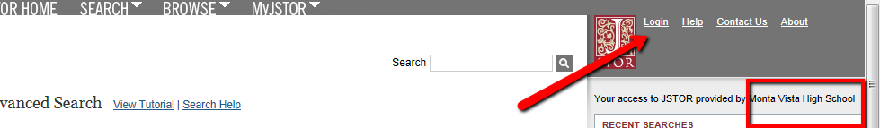
Go to Advanced Search. | 
Check the first box; uncheck the second box.  - This ensures that results include full article, not just a record of the articles | - Include only content I can access  - Include links to external content
Narrow By:  - Item Type (Consider narrowing to “article.”)  - Date  - Language | 
Narrow by Discipline:  - Choose the discipline(s) in which you are researching  - General Science, Health Science, History of Science and Technology | 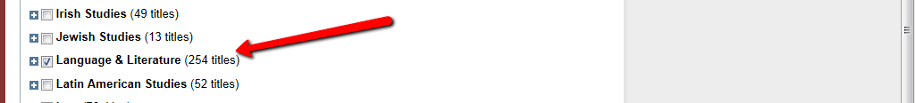
Type in one keyword: ________________  (Choose a keyword that represents the main idea of what you are researching)  Search in “full-text” | How many articles did you get? _______
Try another search. Click on Modify Search. | 
Try phrase searching.  ________________ near 5 __________________ | How many articles did you get? ______
Try combining 2 keywords:  ________________ AND keyword: __________________  Search in “full-text” | How many articles did you get? ________

EBSCO Databases: Searching Activity
What is it and why use it for research?  - It is a database of reference books, magazine, periodical, and newspaper articles, images, and more.  - It is updated daily so has current information.  - The sources are reliable! This saves time from you having to evaluate websites.  - It searches through ALL items in the database at once. This saves time from having to visit different news websites individually. For example, it will look through New York Times, SF Chronicle, and Newsweek (and many more) at the same time. | Go to: http://www.mvhs.fuhsd.org/library  - On the left click on “Research Resources”  - Click on “EBSCO”  - Choose from the database(s) that looks most relevant.  - No password is required if at school.  - For access from home or any computer connected to the internet, use the following – username: mvhs_fuhsd; password: matadors_research
Choose Advanced Placement Source AND Science Reference Center.
Go to Advanced Search. | 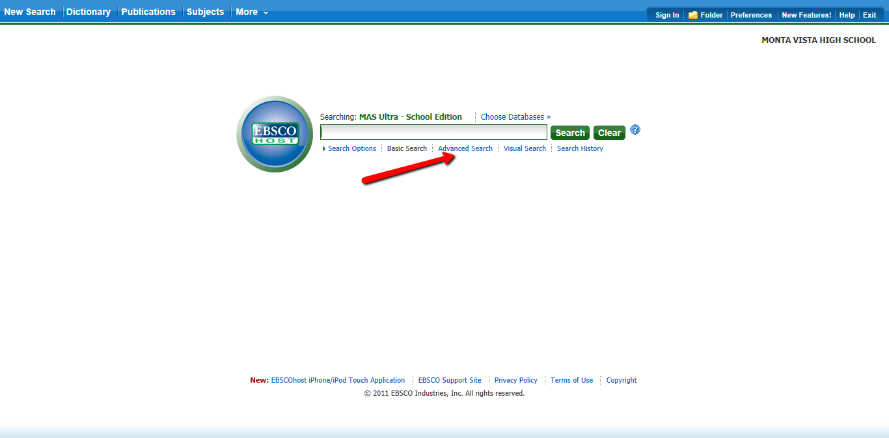
Type in one keyword: ________________ Click: search  (Choose a keyword that represents the main idea of what you are researching) | How many articles did you get? _______
Let’s narrow the search using Boolean Searching:  - Go back to Advanced Search  - Choose Boolean/Phrase  - Choose Full Text  - Limit to Scholarly (Peer Reviewed) Journals | 
Try combining 2 keywords:  ________________ AND keyword: __________________ | How many articles did you get? ________
Try using exact phrase searching:  “________________ __________________”  (The quotes tells the database to look for those words in exactly that order) | How many articles did you get? ______

Try using the wildcard *: __________________  Use this to expand your search to include all forms of a word.  (For example, teen* would include teen, teens, teenager). | How many articles did you get? ________
Add additional databases to expand your search.
Look for helpful articles.  Open the record and browse the following to determine if it will be useful for your research:  - Subject Terms  - Publication date  - Skim the article or abstract. Especially look around the keywords in bold. | 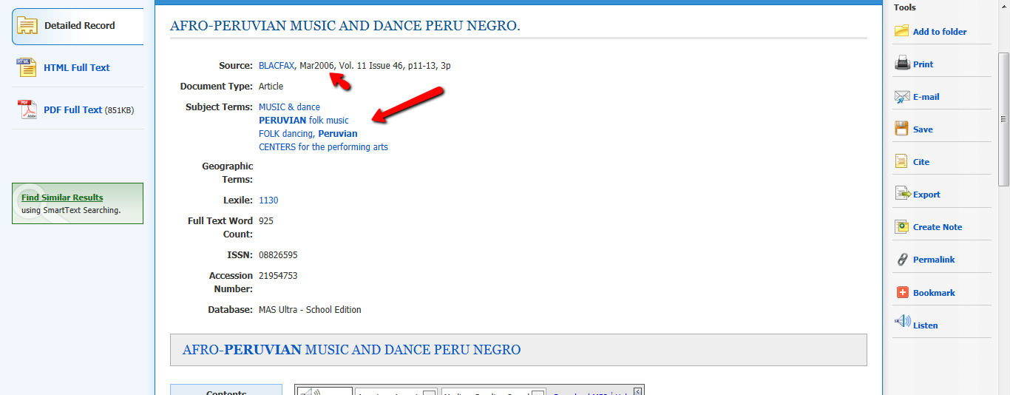
Save for later:  - Create your own log-in to save searches  - Email it to your self | 
Instructions:  Find and save at least THREE articles about your topic. | Article Titles:  1. _______________________________________  2 _______________________________________  3 _______________________________________
Citation:  - EBSCO writes the citation for you.  - Choose APA style  - Copy it from the bottom of the article. | 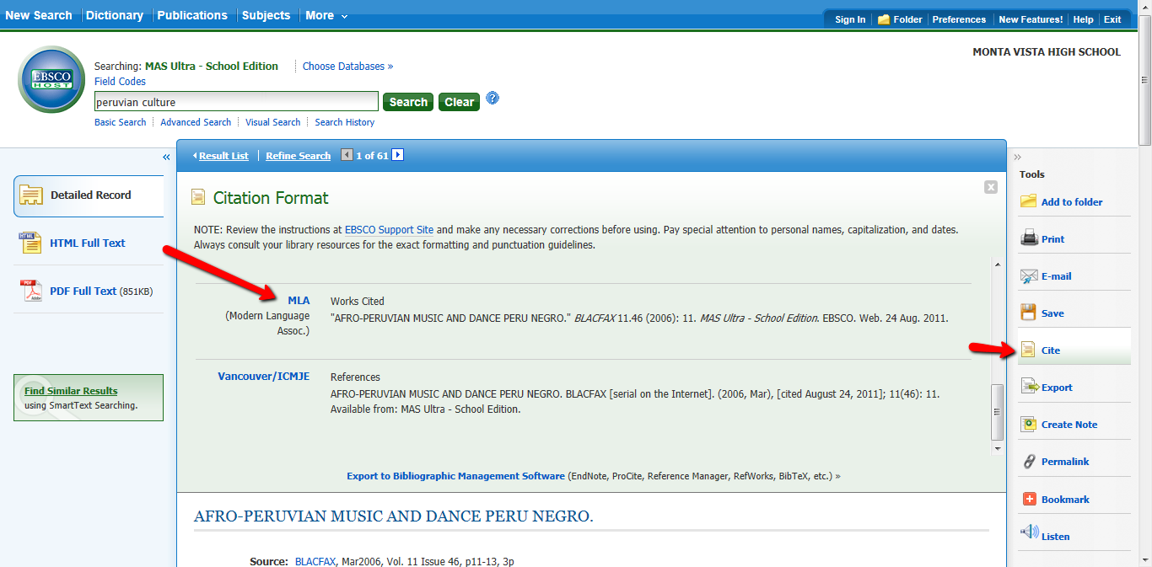
Searching Tips:  If your first search does not give you the results you want, TRY AGAIN!  - Change keywords. (Try synonyms.)  - Broaden or narrow your search with more or less keywords, quotes, or other limiters. | 

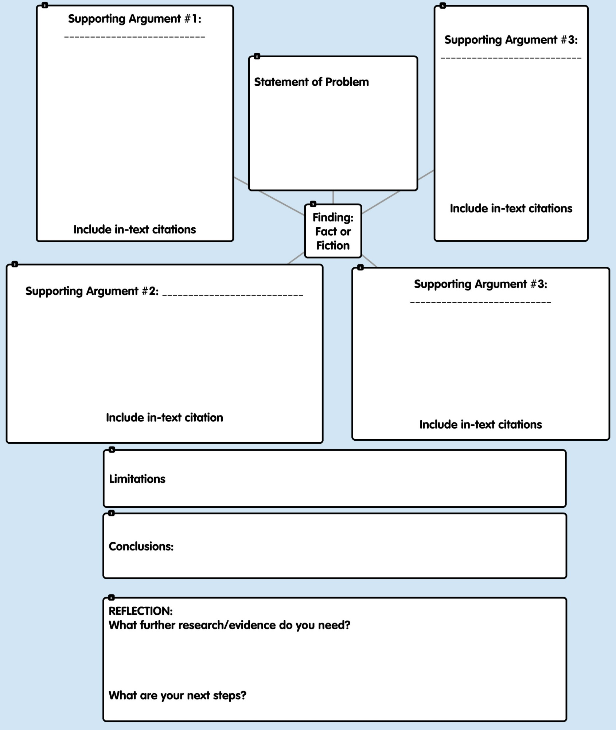
Synthesis Document
Evaluation Form
Please evaluate yourself and each of the other members of your project team by rating each person on the five criteria listed below. Be honest and fair in your assessment of others and yourself. I may talk to your group, if there is a discrepancy in the evaluations.
Rating Scale (points)
5 = Excellent....4 = Very Good......3 = Average....2 = Below Average....1 = Poor

Name: _______________________________________ Period: _______
Movie/TV Show Title ______________________________
Evaluation Criteria:
1. Had good ideas.
2. Did their share of the work.
3. Helped keep the group "on task.".
4. Was cooperative and team oriented.
5. Participated in a responsible manner.
---------------------------------------------------------------------------------------------------------------------
Evaluation of Yourself:
Criterion 1. _____------- Criterion 2. _____ --------- Criterion 3. _____
Criterion 4. _____ ------ Criterion 5. _____ --------- Total Points: _____
---------------------------------------------------------------------------------------------------------------------
Your evaluation of ___________________________________
Criterion 1. _____------- Criterion 2. _____ --------- Criterion 3. _____
Criterion 4. _____ ------ Criterion 5. _____ --------- Total Points: _____
---------------------------------------------------------------------------------------------------------------------
Your evaluation of ___________________________________
Criterion 1. _____------- Criterion 2. _____ --------- Criterion 3. _____
Criterion 4. _____ ------ Criterion 5. _____ --------- Total Points: _____
---------------------------------------------------------------------------------------------------------------------
Your evaluation of ___________________________________
Criterion 1. _____------- Criterion 2. _____ --------- Criterion 3. _____
Criterion 4. _____ ------ Criterion 5. _____ --------- Total Points: _____

Research Paper Grading Rubric: Fact or Fiction AP Chemistry Project
Grading Rubric
Adapted from :CSIS200/WSTU200 – Women in Computer Science

Name:_______________________________________

Introduction  - Is the topic of the paper clearly and concisely introduced?  - Does the introduction include a clear and concise thesis statement?  - Does the information forecast the remainder of the paper for the reader? | _____/5
Body of the Paper  - Does the paper summarize the articles individually, one at a time, or does it provide a thematic summary of the research drawn upon?  - Does the paper provide examples to help the reader understand points made?  - Does the paper synthesize the material reviewed into a few main points?  - Is all information factually correct?  - Does the paper provide excellent background, context and idea development?  - Does the paper include an excellent discussion of detail? | _____/10
Conclusion  - Is there a conclusion?  - Does the paper provide a brief summary of what has been discussed? | _____/5
References & Citations  - Does the body of the paper cite sources as necessary? (2 points)  - Does the paper draw on six journal articles/empirical sources (no more than 2 websites)? (2 points) | _____/10
Quality of Sources  - Are the sources relatively recent? (3 points)  - Is there a variety of sources? (3 points) | _____/10
Writing Style  - Is the paper well organized? (5 points)  - Is the paper free from grammar & spelling errors? (5 points)  - Are there smooth transitions between sections?  - Is the manuscript clean/legible/pleasing to read? | _____/5
Style  - Does the paper follow the margin, font, and page specification found in the paper guidelines? (8 pages, 12-point font, 1” margins, double spacing) | _____/5

Total Points: _____/50
General Comments: Total Points for the project=200, Breakdown: Google Docs Collaboration: 100 points, Research Paper: 50 points, Power point presentation= 50
Sample Topics and Research Questions

Name of TV Show | Problem Statement
Batman Begins | Is it possible to create a conditioned stimulus in order to invoke artificial fear in the amygdala?
Mythbusters | Is zinc gluconate an effective treatment for box jellyfish stings?
House: Skin Deep | How can we identify cardiovascular diseases using MRIs?
Oblivion | Is there any way to store renewable energies for long periods of time and convert it for commercial use?
Star Wars | What elements and temperatures would be required to achieve the light saber's bright and dangerous properties? How much does laser technology need to improve to achieve such goals?
Jurassic Park 1993 | Is it possible to clone dinosaurs from preserved mosquito fossils (which have dinosaur blood)?
Captain America: The First Avenger (2011) | Is it possible to freeze a body and its bodily functions without causing the person to die of frostbite?
Iron Man | Is the arc reactor a practically viable source of energy for Tony Stark's Iron Man suit?
Iron Man 3 | Can Iron Man's suits withstand the extreme temperature generated by flying at high speed from Tennessee to Florida in less than a minute?
Star Wars, Star Trek, Back to the Future, Magic School Bus, Harry Potter | Is it possible for cars to fly?
Breaking Bad | Is it possible for crystalline Mercury II Fulminate to explode with enough force to shatter windows when smashed against the ground?

Sample Google Doc

What’s Remaining:
PLAY THE VIDEO IN CLASS TOMORROW AND WE’RE DONE!

It was fun working with you guys.

-participation rubric---do we get this in class? -done
-research paper edits-done
-edit video(done) + test it out in her class-done
VIDEO UPDATE:
- Shelley pointed out a problem to me, so i’ll begin the process of uploading and publishing again....had to restart again b/c my computer died.
  - saving: done
  - publishing: done
- You can access the video with this link: (it’s the new one)
- http://www.youtube.com/watch?v=tn281AZ5PoE
- Two Problems:
  - we shot the video vertically, so there’s a bunch of awkward space on either side of the video (you’ll be able to see what i mean)
  - it’s 5:00.....YAY!!!!!!!!
NEW PROBLEM STATEMENT: Is it possible for people to walk on Oobleck?
Schedule for Upcoming Days:
1. Shortcomings, Remove calculations, Update Research Paper w/ Peer Edits + Other People (if you know any smart people not in our classes)- May 25
2. Tone of Research Paper- May 26
3. Once over (everyone separately)- May 26
4. Movie clip + Presentation Script- May 27
5. Practice Oral Presentation + Create Props- May 28
6. Make the video- May 28 (at 5)
7. Final edits of Research Paper (Formatting, Flow, and etc.)- May 28 til due date
Please add on to the lists!
Agenda from the Peer Edits (agreed upon):
-The repetitiveness issue
-Integration of the terms in the intro
-A more general/concise intro
- correct citations
Proposed Edits:
-Add those curled starch molecule pictures
-Further defining/ explaining significance of terms (will highlight in orange)
-More pictures/ diagrams in general
-work on flow
Movie Script:
possible topics to talk about:
-A Non-Newtonian Fluid/shear thickening fluid
-more pressure/ concentration of cornstarch → increase in viscosity
-what’s happening at molecular level
-starch composition (swelling of starch granules/ amylopectin/ amylose)
Actual Script:
Roles: (pick which role you want to be)
A:
B:
C:
D:
-Show video clip (2 min~)
- clips of people trying to walk on water and failing
A: Walking on water maybe a difficult task to do.... (watches person C put their foot in the water and fail to walk on it)
-Short briefing of clip to transition into the presentation
A: But we know a secret technique.
B: The secret is that the liquid the lady just ran on in the video is not pure water but rather a suspension of water and cornstarch. To make this mixture called oobleck, all you need is some water, cornstarch, and of course, a container to mix them in. (points to the ingredients)
C: Oh, look! As water is added to the cornstarch, the mixture is becoming thicker and thicker because the cornstarch molecules are swelling.
D: Also, when nothing is touching the Oobleck and you move the tub, you can see that the Oobleck flows like a liquid (move tub), yet when you punch or press on it, the Oobleck acts like a solid.(punch or press Oobleck)
-A: Oobleck is a non- Newtonian, a shear thickening fluid, that does not behave like normal fluid. Its consistency becomes thicker when stress is applied as seen when ____ (person who punched it) punched or pressed on the Oobleck, explaining why Oobleck can act as a solid when someone steps on it, and a liquid when left alone.
-D: (can use pictures when explaining this or playing with Oobleck) At the molecular level, this phenomenon occurs because of the cornstarch molecule’s changing shape. When there is no pressure applied, the cornstarch molecules curl up to form a spherical shape. The water particles squeeze between the curled cornstarch molecules, allowing the cornstarch molecules to easily roll and slide past each other which creates a fluid-like state. (demonstrates how cornstarch rolls ino a ball and show pictures of molecules rolling and sliding past each other)
C: On the other hand, when pressure is applied, the cornstarch molecules uncurl into a linear shape. The water molecules are squeezed out and the remaining cornstarch particles become entangled with other uncurled cornstarch molecules. This creates a solid, since the molecules are unable to move past one another. (can use pictures showing rolled up cornstarch molecules unraveling to linear molecules and show how linear molecules get tangled)
B: And when the pressure is released, the cornstarch molecules will curl up, the water will flow back between the cornstarch particles and Oobleck will flow like a liquid again. (can play with Oobleck)

Props/Posters/Etc. to Create:
-Oobleck! :D
- pictures of cornstarch (curling and uncurling/ sliding against each other(?))
-
Outline for Discussion:
//current research essay’s outline
1. Non Newtonian fluids
- Characteristics of Non-Newtonian fluids
  - how viscosity is dependent on shear stress
  - flow consistency & behavior index, power law necessary
- Characteristics of Dilatant fluids
  - how viscosity dependent on shear stress
2. Two Types of Non Newtonian fluids: rheopectic and dilatant
- Oobleck is a dilatant
viscosity changes because of shear stress
Water- Cornstarch interaction at molecular level
- explains what is going on at molecular level between water and cornstarch and why this causes Oobleck to behave like a solid and a liquid
3. Oobleck’s viscosity dependent on concentration
- refer to graph
  - how increasing concentration → increasing viscosity
4. Structure of Cornstarch
- explains why Oobleck is suspension
- explains why increasing concentration of cornstarch increases viscosity
- explains why water can be easily squeezed out of cornstarch
5.Concept of Calculations
- non-consistency of viscosity in Non-Newtonian liquid
- viscosity and shear stress are directly related
- if person accelerates fast enough, then can walk across cornstarch suspension

Fact or Fiction: Walking on Oobleck, According to Its Chemical Properties

Niveditha Jayasekar
1436 South Stelling Rd, Cupertino, CA, 95014
Christina Li
22413 Ramona Ct, Cupertino, CA, 95014
Shelley Wang
22463 Riverside Dr, Cupertino, CA, 95014
Kristen Wang
10394 Mira Vista Rd, Cupertino, CA, 95014

May 31, 2011

Abstract:
The focus of this research was to investigate the possibility of walking on Oobleck, a mixture of water and cornstarch. This phenomenon was observed in an episode of the Ellen DeGeneres show, as an audience member ran across a vat of this substance. As a non-Newtonian fluid, Oobleck had the ability to act as both a liquid and a solid when exposed to various forces due to its variable viscosity. This changing viscosity was determined by the structure of cornstarch and its interactive properties with water. When less force was applied to it, the suspension behaved more like a liquid and when more force was applied to it, it behaved more like a solid. Through these properties of Oobleck, it was found that it was indeed possible to walk on the fluid given that force was continually applied to it.
Introduction:
People have always been intrigued by the interesting properties of cornstarch, as it flows like a liquid through one’s hands but solidifies when force is applied to it. Steve Spangler, a scientist who appeared on the Ellen DeGeneres show, mixed 2,400 pounds of cornstarch with 240 gallons of water to create a cornstarch suspension, and asked an audience member to dance on it. To the surprise of everyone present, the audience member was able to walk and dance on Oobleck. But, why was a person able to accomplish this feat on a liquid-like substance? The answer to this question lies in Oobleck’s properties as a non-Newtonian fluid. These properties of non-Newtonian fluids have made non-Newtonian fluids indispensable in industrial processes and in our daily lives, since they are used in items ranging from ketchup to cosmetics. As a non-Newtonian fluid, this suspension is able to change its viscosity as force is applied to it. Viscosity is a fluid’s resistance to flow. For example, when a drop of honey and a drop of water are allowed to flow down a tilted plate, the honey will flow slower than water because it has a greater viscosity than water. Assuming that temperature and concentration of cornstarch in the suspension to be constant, the cornstarch suspension is able to change its viscosity because of two additional properties that affect its viscosity: shear stress and shear rate. Shear stress is the force that allows two molecules to slide against each other, such as pounding or pressing. Shear rate is the rate at which shear stress is applied, a gradient of velocity that directly correlates to viscosity. Using our knowledge of the properties of fluids, we conclude that “walking” on water mixed with cornstarch, as seen in television and movies, is indeed a reality.
According to this graph, viscosity of Oobleck is also dependent on the concentration of cornstarch in water. As concentration of cornstarch in water increases, the viscosity of the suspension increases as well.
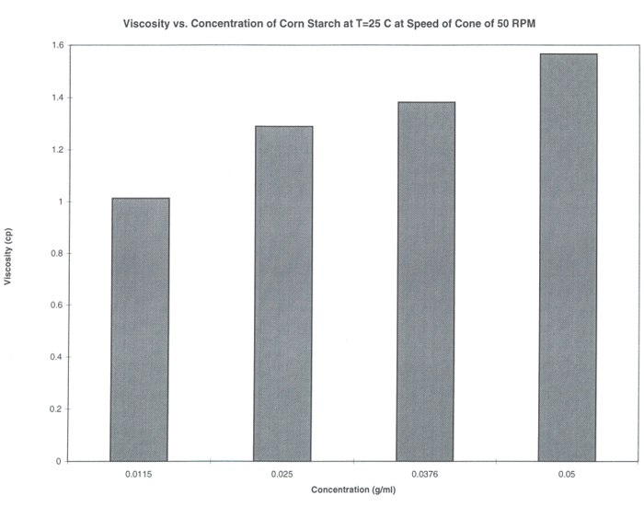
Figure 1 (Phillips, Sheet Chart 16)
The Oobleck used on the Ellen Degeneres is found to have a concentration of 0.36g/mL(mass/volume). Given the concentration and measured viscosity values, it is possible to calculate the amount of force required to support a person through an adjustment of Newton’s viscosity equation, a power-law equation, for non-Newtonian fluids: ^{n}. In this equation, is the force applied on the surface of Oobleck when a person runs across it, is the flow consistency index (which replaces the viscosity coefficient in Newton’s viscosity equation), is the area of the surface in which force is applied, is the shear stress, and ^{n} is the flow behavior index.
Discussion:
The structure of the cornstarch molecules in Oobleck plays a key role in determining Oobleck’s behavior. Starch is a polysaccharide that is insoluble in water and consists of long chains of repeating glucose units (“Starch”). In a starch granule, there are two substances: amylose and amylopectin (Lineback). Typically, a starch molecule consists of 15-30% amylose and 70-85% amylopectin (Lineback). The molecule, amylopectin, is a large polymer that has many branches and due to the orderly bonding of chains and the disorganized branching, has a structure that is partly crystalline and partly amorphous (Zamora, Lineback). Since amylopectin is partly crystalline, it will not be able to easily break into smaller components, creating a rather viscous suspension. The other constituent, amylose is typically a single chained polymer with no branches, containing about 200-20,000 glucose units (Zamora). Since both amylopectin and amylose are larger than simple monatomic ions, they will form a suspension with water instead of dissolving in water. In amylose, the first carbon of one glucose molecule bonds with the fourth carbon of a second glucose molecule (Chaplin). As a result of this bonding between the glucose molecules, amylose forms a single helical structure that, when bonded to another single helix of amylose, produces a double-stranded crystallite (Chaplin). Similarly to amylopectin, this double-stranded crystallite of amylose will also not be able to break apart easily. Thus, Oobleck is indeed a suspension.
As a suspension, Oobleck contains starch molecules that swell in water instead of dissolving in water. When starch is added to water, the starch granules swell and the cornstarch suspension becomes more viscous (Bemiller, Fannon). This swelling action may be seen as some water is added to cornstarch transforming it from a fine powder to a mixture that slowly becomes thicker. When the starch is unable to swell anymore, the mixture will then become less viscous as more water is added to the mixture. Due to this effect, there must be a ten-to-one ratio of cornstarch to water in the suspension for people to be able to walk on the mixture.
Oobleck is quite unique in the sense that it is classified as a Non-Newtonian fluid, which has different flow properties than the typical Newtonian fluid. Unlike the viscosity of Newtonian fluids, the the viscosity of non-Newtonian fluids is dependent on shear stress, shear rate, and environment of the fluid. This dependency makes it more difficult to predict the viscosity of such a fluid without taking into consideration other factors such as the flow consistency index and the flow behavior index (both of which are parts of the power law) that vary with the viscosity of a non-Newtonian fluid (Elert). In addition, the viscosity is also dependent on the force being applied to it, unlike Newtonian liquid, which mainly rely on temperature changes for viscosity changes. Thus, the viscosity of Oobleck is only a measurable quantity. Since the viscosity of Oobleck increases as the force applied increases, it is classified as a shear-thickening fluid (Elert).
Of the non-Newtonian fluids, there are two types of shear-thickening fluids: rheopectic fluids and dilatant fluids. Oobleck is classified as a dilatant, a fluid in which the viscosity increases with increasing shear rate and is unaffected by time (Elert). Typically, the viscosity of dilatant fluids increases roughly at the same rate as the shear stress which can be explained by their property of containing closely-packed particles and a liquid that flows in between the particles. In Oobleck, the cornstarch molecules are the closely-packed particles and water is the liquid that flows in between the cornstarch molecules. Water molecules in Oobleck squeeze between cornstarch molecules rather than forming bonds. This allows the cornstarch particles to slide and roll past each other when the suspension is in liquid form. When stress is applied to cornstarch and water, the long glucose molecules of cornstarch uncurl into straight chains. Shear thickening occurs. The water molecules are squeezed away from the cornstarch particles, the linear cornstarch molecules entangle with adjacent cornstarch molecules, and Oobleck enters a rigid solid-like state (“Oobleck”). When water is unable to properly fill in the gaps between the particles, the solution becomes more viscous, or resistant to flowing like a liquid. As the fluid’s resistance to flow increases, the fluid behaves more like a solid. When the force is released, the reverse process occurs. Water molecules seep back through the starch molecules, cornstarch molecules curl into spherical shapes again, the spherical cornstarch molecules roll around one another, and Oobleck becomes a liquid again. Because of the obstructing water molecules, Oobleck is a dilatant fluid and has the characteristics of a shear-thickening fluid.
The viscosity of Oobleck is not only directly proportional to the force, but it is also directly proportional to concentration of the mixture. As more cornstarch is added to the mixture, the viscosity of the mixture increases. As indicated by the Viscosity vs. Concentration of Cornstarch graph in the introduction, the fluids with the highest concentrations consistently had the highest viscosity in each of the trials with variable conditions of shear stress and temperature. Thus, since the concentration of Oobleck used by Steve Spangler is significantly greater than the tested concentrations of Oobleck, it follows that the viscosity of the cornstarch mixture used in Spangler’s demonstration should be much higher than the mixtures in the graph. With a higher viscosity, the mixture would flow slower, giving more time for a person to remain atop the cornstarch and water suspension in the video.
In our research, one of the key limitations was that we were able to measure the relative viscosity, but could not calculate the exact viscosity in terms of numbers because of Oobleck’s varying viscosity. In order to find the exact viscosity of the fluid, we would have to conduct an experiment in conditions similar to those in the Ellen DeGeneres show and directly measure viscosity of the liquid. Thus, we resorted to finding viscosity relatively instead.
In conclusion, there are various factors that influence the “walking on Oobleck” phenomenon. First of all, the chemical structure of starch molecules in the mixture of cornstarch and water prevents the dissolution of starch molecules. Thus, the cornstarch and water mixture is classified as a suspension. Oobleck is further classified because of its variable viscosity as a non-Newtonian fluid and as a shear-thickening fluid. Because of the characteristics of these classifications, Oobleck is able to become more solid-like when force is applied to it. Therefore, we have concluded that it is possible to walk on a mixture of Oobleck.
Bibliography
1. ASM International. “Oobleck.” 2010. PDF file.
2. Bemiller, James N, and John E Fannon. Structure of Corn Starch Paste and Granule
Remnants Revealed by Low Temperature Scanning Electron Microscopy after
Cryopreparation 69.4 (1992). PDF file.
3. Chaplin, Martin. “Starch.” Water Structure and Science. N.p., 6 Dec. 2010. Web. 21 May 2011. <http://www.lsbu.ac.uk/‌water/‌hysta.html>.
4. Elert, Glenn. "Viscosity." The Physics Hypertextbook. N.p., 2010. Web. 21 May
2011. <http://physics.info/viscosity/>.
5. Lineback, David R. “Starch.” Access Science. McGraw-Hill Companies, n.d. Web. 21 May 2011. <http://www.accessscience.com.rpa.santaclaracountylib.org/‌content.aspx?searchStr= starch+structure&id=651700>.
6. Phillips, Nathan, Erik Royse, and Daisy Sun. Cone and Plate Viscometry. [Pittsburgh]: n.p., 1997. Chemical Engineering at Carnegie Mellon. Web. 22 May 2011. <http://rothfus.cheme.cmu.edu/​tlab/​visc/​projects/​t9_s97/​t9_s97.pdf>.
7. "Starch" A Dictionary of Chemistry. Ed John Daintith. Oxford University Press, 2008. Oxford Reference Online. Oxford University Press. Santa Clara County Library. 22 May 2011 <http://www.oxfordreference.com.rpa.santaclaracountylib.org/views/ENTRY.html?subview =Main&entry=t81.e3879>
8. Zamora, Antonio. “Carbohydrates - Chemical Structure.” Scientific Psychic. N.p., 2005. Web. 21 May 2011. <http://www.scientificpsychic.com/‌fitness/‌carbohydrates1.html>.

Since the viscosity, shear rate, and shear stress of this non-Newtonian fluid are variable and dependent on the force applied to the liquid, it is tricky to calculate whether people can actually walk on this suspension or not and at what speed they must do so. In order to overcome the inconsistency of the viscosity of this fluid and analyze the possibility of walking on Oobleck, we had to make many assumptions about the approximate weight of the person on the cornstarch suspension and the acceleration of that person. When applying the non-Newtonian equation of viscosity to the cornstarch suspension situation in the Ellen DeGeneres’ show, we discovered that viscosity and shear stress are directly related. Thus, the greater the shear stress, the greater the viscosity and the easier it is for a person to be able to stand on the cornstarch suspension.
1.http://www.accessscience.com.rpa.santaclaracountylib.org/content.aspx?searchStr=starch+structure&id=651700
2.http://www.scientificpsychic.com/fitness/carbohydrates1.html
3.http://www.lsbu.ac.uk/water/hysta.html
4 www.mtrl.com/content/docs/oobleck.pdf
5 "starch" A Dictionary of Chemistry. Ed John Daintith. Oxford University Press, 2008. Oxford Reference Online. Oxford University Press. Santa Clara County Library. 21 May 2011 <http://www.oxfordreference.com.rpa.santaclaracountylib.org/views/ENTRY.html?subview=Main&entry=t81.e3879>
6 http://aaccnet.org/cerealchemistry/backissues/1992/69_456.pdf (a primary source)
7 http://authors.library.caltech.edu/16539/1/Wagner2009p6165Phys_Today.pdf (primary source)

http://www.scienceinschool.org/2010/issue14/starch
http://www2.chemistry.msu.edu/faculty/reusch/VirtTxtJml/carbhyd.htm

8. Wagner, Norman J, and John F Brady. "Shear Thickening in Colloidal Dispersions." Physics Today (Oct. 2009): 27-32. Caltech.edu. Web. 19 May 2011. <http://authors.library.caltech.edu/16539/1/Wagner2009p6165Phys_Today.pdf>.

Teacher Questions:
- we can use “we” only in discussion
- tables only in intro
- equations only in intro (we can refer to the equation in the discussion, but not the calculations behind it)
- we can assume stuff into the equations
- only concepts into discussion

Rough Draft:
Title Page
Title: Walking on Fluid: Fact or Fiction
Names: Niveditha Jayasekar, Christina Li, Kristen Wang, Shelley Wang
Addresses: Our addresses or Monta Vista’s? //probably Monta Vistas’
Dates: May 20, 2011

Abstract:
Idea of Purpose: In movies and television shows alike, people of all ages have supposedly walked on water. We conducted thorough research indicating whether this is possible.
Findings: To our surprise, we found that this phenomenon is indeed possible. Due to the characteristics of this Non Newtonian fluid, the suspension of water and cornstarch acts as both a liquid as well as a solid. Although cornstarch does not fully dissolve in water, the water is able to go in between the cornstarch molecules. Normally, the molecules of cornstarch are in a ball shape form and are able to flow past each other smoothly. This occurs when the suspension acts as a liquid; however, when pressure is applied, the molecules become a linear shape and entangle with one another, forming a solid.

Introduction:

People have always been amused by the interesting properties of cornstarch as it flows through our hands like a liquid but solidifies when pressure is such as pounding, rolling into a ball, or even running across is applied to it. As seen in the Ellen Degeneres show, scientist, Steve Spangler, mixes 2400 pounds of cornstarch with 240 gallons of water, creating a Non-newtonian cornstarch suspension. Although the audience witnessed the liquid characteristics of the mixture as it flowed through Spangler’s and Degeneres’s hands, they were amazed to see a woman being able to run across it.
Rationale: As a non-newtonian fluid, a suspension of cornstarch and water is able to change its viscosity as force is applied to it. This property of non-newtonian fluids has made them indispensable in industrial processes and our daily lives, appearing from ketchup to cosmetics. Not only is this topic very applicable in daily life, it is very interesting to know whether or not people can really walk on a water suspension. We have seen in television and magazines people “walking” on water, and it has piqued our curiosity about how it would be possible to achieve this feat through the properties of fluids.
Defining Terms: In order to understand how the suspension of the cornstarch is able to act solid-like and allow a person to run quickly across the suspension, it is important to define the following terms. Viscosity, shear stress, and shear rate are measurable properties of all fluids. Viscosity is a measure of a fluid’s resistance to flow caused by shearing stress. Shear rate is a gradient of velocity that directly correlates to viscosity. Shear stress is the force that makes two fluids slide against each other. The suspension of cornstarch in water, Oobleck, is a type of Non-Newtonian fluid. A Non-Newtonian fluid is a fluid whose viscosity is variable to applied stress. Oobleck is also a dilatant liquid, whose viscosity increases with the rate of shear and a shear-thickening fluid that becomes more solid-like when agitated.

c. Introduction
Introduction is a brief section (usually less than one page) designed to inform the reader of the relevance of your research and includes a short history or relevant background that leads to statement of the problem being addressed. The introduction will summarize the relevant literature so the reader will understand why you were interested in the question that you researched. Introductions usually start broad and then narrow down focusing on the problem that you are trying to solve or question that you are trying to answer.
i. Provides sufficient context or background for your reader to understand why you did your research, including visual aids (drawings).
ii. Define the terms and abbreviations that your reader may not know.
iii. Develop rationale for your work.
On an airing of the Ellen Degeneres show, Steve Spangler demonstrated someone “walking on water,” or actually running across it. The water was actually made from cornstarch and water, which allowed the person to successfully run across the water due to it being a Non-Newtonian Fluid.
Relevance of research (background/context of our research):
Visual Aids:
(if want to, can show picture of cornstarch: http://www.accessscience.com.rpa.santaclaracountylib.org/content.aspx?searchStr=starch+structure&id=651700)
Summary of our clip: In Ellen Degeneres’s show, Steve Spangler mixes 2400 pounds of cornstarch with 240 gallons of water, creating a Non-newtonian cornstarch suspension. Although the audience witnessed the liquid characteristics of the mixture as it flowed through Spangler’s and Degeneras’s hands, they were amazed to see a woman being able to run across it.
Rationale:
Terms/ Abbreviations our readers may not know:
Non-newtonian fluids: a fluid whose viscosity is variable based on applied stress
shear stress: the force tending to make part of the fluid slide past another part
viscosity: a measure of a fluid’s resistance to flow caused by shearing stress
shear rate: gradient of velocity (correllates to viscosity)
- 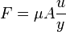 (Newton’s Equation, for Newtonian fluids)
shear thickening fluid: a fluid that becomes solid-like when agitated
dilatant: material whose viscosity increases with the rate of shear

1st Rough Draft:
Due: May 20th, our target: 18th?
NOTE: References (Works Cited-NOT Required)
a. Title Page: Select an informative title for your research paper. Include the name(s) and address(s) of all authors, and the date submitted.
i. Title should be informative and concise
ii. All nouns are capitalized in the title.
iii. Title is centered on the page
iv. Your names, addresses, dates appear under the title.
b. Abstract: The summary of your research should be 200 words or less. Write your summary after the research paper is completed. The summary gives the reader a “preview” of what is to come and should include an idea of purpose and your findings in this case.
i. Abstract is single paragraph and concise.
ii. It is written in past tense.
iii. Abstract should be able to stand on its own.
iv. Don’t use abbreviations or citations in the abstract.
c. Introduction: Introduction is a brief section (usually less than one page) designed to inform the reader of the relevance of your research and includes a short history or relevant background that leads to statement of the problem being addressed. The introduction will summarize the relevant literature so the reader will understand why you were interested in the question that you researched. Introductions usually start broad and then narrow down focusing on the problem that you are trying to solve or question that you are trying to answer.
i. Provides sufficient context or background for your reader to understand why you did your research, including visual aids (drawings).
ii. Define the terms and abbreviations that your reader may not know.
iii. Develop rationale for your work.
d. Methods: We will not include this since you only reviewed the literature and did not conduct experiments.
e. Results: Since you did not conduct the experiment, we will skip this section as well.
f. Tables and Graphs: Not relevant to us in this specific research paper but is usually a significant part of the research.
g. Discussion: This is where you will report your findings and interpret your results. How do the result of research relate to your question. What did your discover? Is the concept used in the movie/media fact or fiction? Why? This is where you can even use “excerpts” from various articles used to support your answer. This is your chance to show your ability to synthesize, support and reason effectively. This is the main body of your paper and it should be no longer than 5 pages double spaced, typed.
i. Interpret your findings in discussion
ii. Explain key limitations- some things that can be researched further or left unanswered.
iii. Discuss the published work and provide conclusions from it.
a. Title Page
Title: The Viscosity of a Non Newtonian Shear thickening fluid: Cornstarch Suspension
Names: Niveditha Jayasekar, Christina Li, Kristen Wang, Shelley Wang
Addresses: 21840 McClellan Rd, Cupertino, CA 95014
Dates:

b. Abstract (past tense!)
Idea of Purpose: In movies and television shows alike, people of all ages have supposedly walked on water. We conducted thorough research indicating whether this is possible or not .
Findings: To our surprise, we found that this phenomenon is indeed possible. Due to the characteristics of this Non Newtonian fluid, the suspension of water and cornstarch acts as both a liquid as well as a solid. Although cornstarch does not fully dissolve in water, the water is able to go in between the cornstarch molecules. Normally, the molecules of cornstarch are in a ball shape form and are able to flow past each other smoothly. This occurs when the suspension acts as a liquid; however, when pressure is applied, the molecules become a linear shape and entangle with one another, forming a solid.

c. Introduction
Introduction is a brief section (usually less than one page) designed to inform the reader of the relevance of your research and includes a short history or relevant background that leads to statement of the problem being addressed. The introduction will summarize the relevant literature so the reader will understand why you were interested in the question that you researched. Introductions usually start broad and then narrow down focusing on the problem that you are trying to solve or question that you are trying to answer.
i. Provides sufficient context or background for your reader to understand why you did your research, including visual aids (drawings).
ii. Define the terms and abbreviations that your reader may not know.
iii. Develop rationale for your work.
On an airing of the Ellen Degeneres show, Steve Spangler demonstrated someone “walking on water,” or actually running across it. The water was actually made from cornstarch and water, which allowed the person to successfully run across the water due to it being a Non-Newtonian Fluid.
Relevance of research (background/context of our research):
Visual Aids:
-oobleck
Summary of our clip: In Ellen Degeneres’s show, Steve Spangler mixes 2400 pounds of cornstarch with 240 gallons of water, creating a Non-newtonian cornstarch suspension. Although the audience witnessed the liquid characteristics of the mixture as it flowed through Spangler’s and Degeneras’s hands, they were amazed to see a woman being able to run across it.
Rationale:
Terms/ Abbreviations our readers may not know:
Non-newtonian fluids: a fluid whose viscosity is variable based on applied stress
shear stress: the force tending to make part of the fluid slide past another part
viscosity: a measure of a fluid’s resistance to flow caused by shearing stress
shear rate: gradient of velocity (correllates to viscosity)
- (Newton’s Equation, for Newtonian fluids)
shear thickening fluid: a fluid that becomes solid-like when agitated
dilatant: material whose viscosity increases with the rate of shear

f. Tables and Graphs (maybe?) (for now, put in tables and graphs from other research papers---later, confirm with gupta)

g. Discussion
The suspension of water and cornstarch, or oobleck, is classified as a Non-Newtonian shear-thickening fluid, explaining the solid and liquid-like characteristics of oobleck. There are two types of shear-thickening fluids: rheopectic and dilatant. Oobleck is a dilatant as the viscosity does not change due to time, but is rather about roughly proportional to shear stress. When the shearing stress increases, the viscosity increases as well, causing the fluid to behave more like a solid.
Clip is fact.
Support:
- Non-Newtonian fluids are more viscous than ordinary fluids, including water.
  - non- newtonian fluid- dependent on rate of shear and time
  - shear stress- applied force (force tending to make part of the fluid slide past another part)
  - viscosity- a measure of a fluid’s resistance to flow caused by shearing stress (generally dependent on temperature and pressure), formally the ratio of shearing stress (F/A) to the velocity gradient
    - (Newton’s Equation, for Newtonian fluids)
      - where F= viscous force
      - μ = viscosity coefficient (proportionality factor)
      - A = area
      - = rate of shear deformation (velocity gradient)
    - In a Non-Newtonian fluid, the constant coefficient of viscosity cannot be defined (Thakur) http://www.ripublication.com/ijeav1/ijeav2n4_9.pdf
    - The viscosity is not constant
  - shear thickening fluid- fluid becomes solid like when agitated
    - dilatant: viscosity proportional to shear stress (more stress, more viscous) and viscosity doesn’t change over time
Starch is an insoluble solid consisting of long chains of polymers. It is a polysaccharide that is made up of thousands of repeating monosaccharides which are glucose. In a starch granule exists two substances, amylose and amylopectin (2). Typically a starch molecule consists of 10-20% amylose and 80-90% amylopectin (2). Amylose creates a dispersion in water where as amylopectin is insoluble in water (2). Amylose is mostly an unbranched chain and there are about 900- 1000 glucose units existing in the structure of corn amylose (1). Due to the helical form of amylose as a result of the bond angles formed between the glucose units, a hydrophobic surface forms which cannot hold water very well and causes the high viscosity in starch-water mixtures (3). The other molecule in starch is amylopectin, a large polymer, that contains about 20-26 glucose units (1). Amylopectin is naturally part crystalline and part amorphous and the chains that connect within amylopectin are what creates the crystalline part of the starch (3).

1.http://www.accessscience.com.rpa.santaclaracountylib.org/content.aspx?searchStr=starch+structure&id=651700
2.http://www.scientificpsychic.com/fitness/carbohydrates1.html
3. http://www.lsbu.ac.uk/water/hysta.html
- Starch is an insoluble amorphous solid consisting of long chains of polymers
  - a polysaccharide made up of thousands of repeating units called monosaccharides (the monosaccharides are usually glucose in common polysaccharide like starch)
  - made up of 10-20% amylose and 80-90% amylopectin (http://www.scientificpsychic.com/fitness/carbohydrates1.html）
    - amylopectin is insoluble, amylose creates a dispersion in water (http://www.scientificpsychic.com/fitness/carbohydrates1.html)
    - Granules of starch contain amylopectin that are part crystalline and part amorphous. The chains that connect within amylopectin are what creates the crystalline part of the starch. (http://www.lsbu.ac.uk/water/hysta.html)
    - The structure of amylose is what gives the high viscosity in starch pastes. The helical form (because of the bond angles formed between the glucose units) ←(http://www.scientificpsychic.com/fitness/carbohydrates1.html)of amylose creates a hydrophobic surface that causes it to not be able to hold water very well. (http://www.lsbu.ac.uk/water/hysta.html)
    - amylose bonds with itself to form gels in solutions (http://www.accessscience.com.rpa.santaclaracountylib.org/content.aspx?searchStr=starch+structure&id=651700)
limitations
- starch doesn’t fully dissolve in water it is more of a suspension http://www.springerlink.com/content/585m28127275221u/
  - The starch molecule “rolls up” from both ends and becomes somewhat of a spherical shape that might resemble BB’s.
    - When slowly stirred, the starch “balls” roll around each other and the mixture has fluid properties.
  - When a larger amount of shear force is applied, the molecule uncurls and becomes more linear. These molecules then entangle and the mixture becomes rigid like a solid.
The addition of water to starch acts as more of a colloidal suspension than a solution because the glucose molecules in starch do not fully dissolve in water. Rather than bonds being formed, the water molecules squeeze in between the present starch molecules. When there is no pressure applied to the suspension, the long chains of starch molecules rolls up from both ends to form a spherically shaped ball. As an individual stirs the mixture, the spherically shaped balls roll around one other to exemplify a fluid like state. On the other-hand, when cornstarch and water is agitated, the long glucose molecules of starch uncurls into straight chains. With water between these linear molecules, the molecules cannot bond to one another. Instead, the linear molecules get tangled with adjacent molecules forming a rigid solid-like state. (4)
4). www.mtrl.com/content/docs/oobleck.pdf (secondary source)

- Gelatinization occurs when cornstarch is added with water
  - intermolecular forces of starch chains are broken as new bonds (double helixes) are formed ///are we still doing double helixes/gelatinization?
    - amylose forms double helices that may aggregate to each other with hydrogen bonds (creating a semi-crystalline structure)
  - solution becomes more solid-like (it thickens)
  - Consider: heat in a cement truck?
- Calculation
  - start with 2,400 pounds of cornstarch + 240 gallons of water (10:1 ratio)
    - what is the viscosity of this solution?
    - http://ddr.nal.usda.gov/dspace/bitstream/10113/26014/1/IND83040351.pdf
      - how viscosity is affected based on amount of water and cornstarch
    - the higher concentration of cornstarch in water and the higher the temperature (for dissolving and gelatinization) = higher shear rates & higher viscosity
  - how much viscosity is needed to support the weight of a person (viscosity-molecular weight relationship
    - equations:
      - F = ma (force = mass*acceleration) (units for acceleration: change in velocity per unit second)
      - http://physics.info/viscosity/ (shelley found another equation) (ctrl+f “power law”) (shelley= currently unsure how to find “K” though)
      - so: ma = nA u/y ….n = viscosity co-efficient
      - http://www.znaturforsch.com/aa/v57a/s57a0863.pdf
    - substitution of values:
      - mass of human (typically 100-200 pounds ) -approx 150 pounds
        - 100lbs = 45.35 kg
        - 150lbs= 68.03 kg
        - 200lbs= 90.71 kg
      - acceleration of dancing audience member- abt 11m/s^2
        - use the video to estimate? //not possible?
        - probably not possible, but for now...we’ll find out the minimum acceleration needed for a person to be able to run across/dance on the thing
        - use kinetic energy?
      - F = ma = 748.43 N
      - A = 7*3 ft = 21 ft
        - surface area of foot = (1*.4166)*2 = .833ft
      - temperature: RTP = 20 deg C (in Ellen DeGeneres room)
        - viscosity co-efficientq
      - concentration of solution (% V/v) = 48L cornstarch/956L (5%)
        - % m/v = ///0.26% WHAT DO WE DO NOW???
      - shear rate = 10.36 s^-1
THIS IS IT: http://sanignaciocollege.com/repositorioaps/0/0/not/articulo_journal_agricultural/articulo_achira.pdf
http://rothfus.cheme.cmu.edu/tlab/visc/projects/t9_s97/t9_s97.pdf (@ 25 degrees, Oobleck is newtonian, n=1)
  - viscosity coefficient: 3.44

- faculty.ksu.edu.sa/othman/CHE312/Lecture%20Notes/3.5.doc (good for calculating)
- http://books.google.com/books?id=-QEfJ_U9tAAC&pg=PA46&lpg=PA46&dq=flow+behavior+index+of+corn+starch+suspension&source=bl&ots=bwyuNtD2Nh&sig=GbSn4c_PNULbl9DfWM_7DKxJl0E&hl=en&ei=Y5jUTZS3KpO0sAPbnonMBw&sa=X&oi=book_result&ct=result&resnum=4&ved=0CDcQ6AEwAw#v=onepage&q=flow%20behavior%20index%20of%20corn%20starch%20suspension&f=false (best equations of all for viscosity)
- http://www.ecs.umass.edu/mie/faculty/rothstein/pub_files/Rheologica_Acta_2010_online_first.pdf (has actually done viscosity calculations but for 55% concentration of cornstarch in water)
http://rpaulsingh.com/problems/Ex2_23.htm (might be helpful in calculating)
-Length of pipe: 2.1336 m
Pre-Approval Form:
Due: May 16th, our target: May 13th

Name of Movie: Mythbusters
http://www.youtube.com/watch?v=5GWhOLorDtw
http://www.schooltube.com/video/de7d2fbd5020acd485ab/Cornstarch-Walk-on-Water-Spangler-on-The-Ellen-Show

Problem Statement:
Is it possible to walk on a solution of 200 gallons of water and 1000 pounds of cornstarch?

Summary of Chemistry Concept:
Cornstarch and water, or Oobleck, is classified as a Non-Newtonian shear thickening fluid, which is a fluid in which the viscosity depends on the force applied to the liquid or how fast an object is moving through the liquid. While most liquids become less viscous when there is change in temperature and pressure, Oobleck’s chemical structure causes it to become more viscous and enters solid phase when force is applied to it. Starch, the main ingredient, is an insoluble amorphous solid consisting of long chains of polymers. When added to water, the amorphous parts of starch begin to move as intermolecular forces of starch chains are broken. Adding water to starch also increases the randomness in the starch structure and decreases the amount of crystalline parts, thus forming a crystalline liquid/ Non-Newtonian fluid. When pressure is applied to the mixture, the water molecules in between the starch molecules are squeezed out and the starch molecules are able to grab hold to each other, causing the mixture to obtain solid characteristics.

notes:
- Cornstarch and water: Non-newtonian fluids/ Nematic liquid crystal
-also called oobleck
-Nematic liquid crystals (LCs) are fluids made anisotropic by the spontaneous appearance of long-range molecular orientational order
-molecules of a nematic liquid crystal are able to have any orientation in the surface plane scientists based their model for Obleck’s behavior on chemical structure.
- Starch is an insoluble amorphous solid consisting of long chains of polymers (glucose)
- The amorphous parts of starch begin to move about as the starch chains form double helixes as gelatinization occurs
- cis the process that breaks down the intermolecular bonds of starch molecules in the presence of water and heat
-the process where intermolecular forces of starch chains are broken as new bonds (double helixes) are formed
- fluids that have cross-linkers that form bonds able to be broken and reformed
-the usual liquid-gas transition is absent in dipolar fluids due to strong chaining
-The coexisting phases are dilute gas with chain ends that exists with a high-density liquid
- cornstarch made up of long chains of repeating units called sugars
-definition of non-newtonian: A fluid whose viscosity changes when the gradient in flow speed changes. Colloidal suspensions and polymer solutions like ketchup and starch/water paste are non-Newtonian fluids.
-The cornstarch mixture called “non-Newtonian” since its viscosity also depends on the force applied to the liquid or how fast an object is moving through the liquid. (from: http://scifun.chem.wisc.edu/homeexpts/lumpyliquids.htm)
-cornstarch is a solid because molecules stick strongly together
-becomes liquid when mixed with water because water molecules get between cornstarch molecules
-It is a Non-Newtonian shear thickening fluid (shearing stress= force tending to make part of the fluid slide past another part)
-the cornstarch will not stay mixed with the water indefinitely. Over time, the grains of cornstarch will separate from the water and form a solid clump at the bottom
-Starch is made up of long chains of glucose molecules, and it is not soluble in water

Primary sources:
http://find.galegroup.com/gps/infomark.do?&contentSet=IAC-Documents&type=retrieve&tabID=T002&prodId=IPS&docId=A68147286&source=gale&srcprod=SRCG&userGroupName=cupe17751&version=1.0

http://www.me.gatech.edu/hu/Publications/Hu10.pdf
http://www.personal.psu.edu/mcd18/natmat.pdf

Determination of Starch to Water Ratio
http://www.aaccnet.org/cerealchemistry/backissues/1990/67_551.pdf

Comparison Between Newtonian and Non-Newtonian Fluids: http://www.ripublication.com/ijeav1/ijeav2n4_9.pdf

Mobility of Water in Corn Starch Suspensions Determined by Nuclear Magnetic Resonance: http://onlinelibrary.wiley.com/doi/10.1002/star.19870390304/abstract

Mobility of “Unfreezable” and “Freezable” Water in Waxy Corn Starch by 2H and 1H NMR: http://pubs.acs.org/doi/abs/10.1021/jf9609441

Colloidal ordering from phase separation in a liquid-crystalline continuous phase:
http://web.ebscohost.com/scirc/pdfviewer/pdfviewer?vid=3&hid=9&sid=5d3cccbe-8fd7-4e1b-a6e4-79b5d21f5308%40sessionmgr112

Secondary Sources:
Oobleck’s intermolecular parts:
www.mtrl.com/content/docs/oobleck.pdf
Solids, Liquids, and Something in Between: http://www.ccmr.cornell.edu/education/ask/index.html?quid=14

Gelatinization
http://docs.google.com/viewer?a=v&q=cache:PYVyfu1u6ecJ:www.insta-pro.com/pdfs/Starch-Gelatinization.pdf+gelatinization&hl=en&gl=us&pid=bl&srcid=ADGEESiDMeCaK0IUsC2EG2n6aJmeHDbTba296gumPZ9N0N1LLsWlx8lYLatxoTyc8Q3zoQiSTD31jo5OWXd4QAF8Tud6vqi-U9o-YOt1ZshoGaqq5t4fKNJYzPuNv6jnjN6m8k5mbQyN&sig=AHIEtbSRJdjtfqLrNVi42EIAy-mG5zu3NQ

Starch composition
www.msstate.edu/org/fsfa/Vol1/4-1-waniska.htm
http://www.lsbu.ac.uk/water/hysta.html

Viscosity
http://find.galegroup.com/gps/retrieve.do?contentSet=EBKS&resultListType=RESULT_LIST&qrySerId=Locale%28en%2C%2C%29%3AFQE%3D%28K0%2CNone%2C19%29non+newtonian+fluid%24&sgHitCountType=None&inPS=true&sort=Relevance&searchType=BasicSearchForm&tabID=T001&prodId=IPS&searchId=R5&currentPosition=1&userGroupName=cupe17751&docId=CX3418502405&docType=EBKS&contentSet=EBKS

http://go.galegroup.com/ps/retrieve.do?sgHitCountType=None&sort=RELEVANCE&inPS=true&prodId=GVRL&userGroupName=cupe17751&tabID=T003&searchId=R1&resultListType=RESULT_LIST&contentSegment=&searchType=BasicSearchForm&currentPosition=1&contentSet=GALE|CX3418502405&&docId=GALE|CX3418502405&docType=GALE&role=

http://www.sciencetext.com/walking-on-water.html
http://physics.info/viscosity/
http://www.luiw.ethz.ch/FC_Labor/Projekte/Wasserwirtschaft/Rheology_and_non-Newtonian_fluid.pdf (a powerpoint but I think it might be a good way to understand the connection between viscosity and non- newtonian fluids)
http://www.stevespanglerscience.com/behind-the-scenes-at-ellen.html

OObleck-A Non-newtonian Fluid
polymer.matscieng.sunysb.edu/forms/Non-Newtonian_fluid.doc

Chemical Concepts + Formulas:
- viscosity concept and equation
  - http://www.fofweb.com.rpa.santaclaracountylib.org/Science/default.asp?ItemID=WE40
  - http://physics.info/viscosity/
  - http://www.nzifst.org.nz/unitoperations/flfltheory3.htm

Walking on Water:
Isotropy = cornstarch and water
Mythbusters movie (green thixotropy)
http://fusionaut.videosift.com/video/Mythbusters-Walking-on-Water-Cornstarch
- isotropy vs. thixotropy: thixotropy becomes liquid when agitated
- becomes liquid as it is agitated and solid when something is placed on it
http://www.stevespanglerscience.com/science-video/steves-february-ellen-appearance
Remo Williams: The Adventure Begins
You can see it at @:50:
http://www.youtube.com/watch?v=5_2sx27EE…

Thixotropy:
-At the microscale, thixotropy iinvolves phenomena such as contact creep and interparticle force redistribution, homogenization of pore pressure (in saturated and partially saturated soils), altered ionic distribution and mobility, and the effects of the loose finer fraction
- http://pmrl.ce.gatech.edu/papers/Diaz-Rodriguez_1999a.pdf (paper on thixotropy)

how thixotropy is used in daily life: http://loyno.edu/lucec/natural-history-writings/thixotropy-important-concept-beach-ecology

Being There
It's the final scene in the movie. You can see it here:
http://www.youtube.com/watch?v=NfMCeidJ8…

Hero (2002)
Here's the scene:
http://www.youtube.com/watch?v=vGq6FXcpx…

Understanding Concept:
http://www.ias.ac.in/womeninscience/aruna_comp.pdf

Primary:
http://www.me.gatech.edu/hu/Publications/Hu10.pdf
http://www.personal.psu.edu/mcd18/natmat.pdf

Comparison Between Newtonian and Non-Newtonian Fluids: http://www.ripublication.com/ijeav1/ijeav2n4_9.pdf

Mobility of Water in Corn Starch Suspensions Determined by Nuclear Magnetic Resonance: http://onlinelibrary.wiley.com/doi/10.1002/star.19870390304/abstract

Mobility of “Unfreezable” and “Freezable” Water in Waxy Corn Starch by 2H and 1H NMR: http://pubs.acs.org/doi/abs/10.1021/jf9609441

Colloidal ordering from phase separation in a liquid-crystalline continuous phase:
http://web.ebscohost.com/scirc/pdfviewer/pdfviewer?vid=3&hid=9&sid=5d3cccbe-8fd7-4e1b-a6e4-79b5d21f5308%40sessionmgr112

Secondary:
Solids, Liquids, and Something in Between: http://www.ccmr.cornell.edu/education/ask/index.html?quid=14

Viscosity
http://find.galegroup.com/gps/retrieve.do?contentSet=EBKS&resultListType=RESULT_LIST&qrySerId=Locale%28en%2C%2C%29%3AFQE%3D%28K0%2CNone%2C19%29non+newtonian+fluid%24&sgHitCountType=None&inPS=true&sort=Relevance&searchType=BasicSearchForm&tabID=T001&prodId=IPS&searchId=R5&currentPosition=1&userGroupName=cupe17751&docId=CX3418502405&docType=EBKS&contentSet=EBKS

http://www.sciencetext.com/walking-on-water.html

OObleck-A Non-newtonian Fluid
polymer.matscieng.sunysb.edu/forms/Non-Newtonian_fluid.doc
Invisibility Cloak:
Websites: http://www.mse.umd.edu/whatismse/metamaterials.html (Sort of talks about what metamaterials are)
Really good at explaining how invisibility works:
http://news.nationalgeographic.com/news/2008/08/080812-invisibility-cloak.html
http://spectrum.ieee.org/biomedical/imaging/metamaterials-breakthrough-brings-invisibility-closer
Really good at explaining how light refraction works:
http://people.ee.duke.edu/~drsmith/negative_index_about.htm

If we’re going to be doing invisibility, I looked over the websites I found above and summarized what they were talking about to give an overview of invisibility. Basically they say that invisibility works because the object (or in this case, the cloak) has a negative refractive index (which means it bends light backwards or at a negative angle- talks about it in http://people.ee.duke.edu/~drsmith/negative_index_about.htm)
The websites also talked about how the object may seem invisible because it bends the lightwaves so that it can curve around the object and then reconnect behind it like how water flows around a boulder and reconnects behind it in a stream. (refractive index is the measure of how much materials can bend a beam of light through them)
Primary:
A Rigorous Analysis of Plane-Transformed Invisibility Cloaks
- http://arxiv.org/ftp/arxiv/papers/1102/1102.1584.pdf (PRIMARY!!!)
- http://ieeexplore.ieee.org/Xplore/login.jsp?url=http%3A%2F%2Fieeexplore.ieee.org%2Fiel5%2F8%2F5338646%2F05169930.pdf%3Farnumber%3D5169930&authDecision=-203

Coordinate Transformations Make Perfect Invisibility Cloaks With Arbitrary Shape
- http://iopscience.iop.org/1367-2630/10/4/043040/pdf/1367-2630_10_4_043040.pdf

Scattering Characteristics of Simpliﬁed Cylindrical Invisibility Cloaks
- http://web.mit.edu/biwu/www/transformation/pdf/QiuM_Scattering%20characteristics%20of%20simplified%20cylindrical%20invisibility%20cloaks.pdf
Secondary:
- http://www.msnbc.msn.com/id/15329396/ns/technology_and_science-innovation/t/cloak-invisibility-fact-or-fiction/
- http://people.ee.duke.edu/~drsmith/cloaking.html
- http://find.galegroup.com/gps/retrieve.do?contentSet=IAC-Documents&qrySerId=&inPS=true&tabID=T002&prodId=IPS&searchId=R4&retrieveFormat=PDF&currentPosition=1&userGroupName=cupe17751&resultListType=RESULT_LIST&sort=DateDescend&docId=A167824189&noOfPages=2

Picture (this really helps show how it works!)
- http://www.google.com/imgres?imgurl=http://static.howstuffworks.com/gif/invisibility-cloak-system.gif&imgrefurl=http://science.howstuffworks.com/invisibility-cloak4.htm&h=368&w=400&sz=26&tbnid=syDCYwyeE61vcM:&tbnh=114&tbnw=124&prev=/search%3Fq%3Dinvisibility%2Bcloak%26tbm%3Disch%26tbo%3Du&zoom=1&q=invisibility+cloak&hl=en&usg=__pw87U0s3i4gZnjwg5CUjx07L9Ks=&sa=X&ei=d7DITe6lMKPYiAKelo2EBQ&ved=0CDMQ9QEwAg
- http://science.howstuffworks.com/invisibility-cloak.htm

Video (this is just to help us understand how it works)
- http://www.guardian.co.uk/science/2011/feb/01/scientists-invent-invisibility-cloak
- www.youtube.com/watch?v=PD83dqSfC0Y
Ideas:
Format:
- Idea
  - concept
  - primary resources
  - secondary resources
  - additional info
Brainstorm Ideas:
- Harry Potter
  - the invisibility cloak
  - use already existing fact or fiction for invisibility in general
one website that I found: http://xlab.me.berkeley.edu/research/OpticalCloak.html
- Superman (i think this would be too broad)
  - crystal--> land
- Sky High
  - using magnetism(in body) to make tech products
- Pikachu
  - Lightning (static electricity? electrolytic cell? battery?)
- http://www.oup.com/us/companion.websites/9780195326925/pdfs/Chem_Movies_Short_Summaries.pdf
- http://www.chm.bris.ac.uk/webprojects2006/Macgee/Web%20Project/home_page.htm
http://www.msnbc.msn.com/id/36520461/ns/technology_and_science-innovation/t/how-far-are-real-superhero-powers/

Final Draft:
- Due: May 31st, our target: May 28th?
a. NOTE: ADD References:
i. In the text, cite the literature in appropriate places- author name, date, ex. Gupta (2011).
ii. In the reference section, list citations in the alphabetical order.
You can use www.citationmachine.net or noodle bib to generate citations for your research

Kudos!! Your group is far ahead of others!! Mrs. Gupta

5."polysaccharide" A Dictionary of Chemistry. Ed John Daintith. Oxford University Press, 2008. Oxford Reference Online. Oxford University Press. Santa Clara County Library. 21 May 2011
6. "starch" A Dictionary of Chemistry. Ed John Daintith. Oxford University Press, 2008. Oxford Reference Online. Oxford University Press. Santa Clara County Library. 21 May 2011 <http://www.oxfordreference.com.rpa.santaclaracountylib.org/views/ENTRY.html?subview=Main&entry=t81.e3879>

- (6) insolubility explains why oobleck is a suspension

Comments From David & Delia
Abstract:
-supposed to be able to stand on its own; a summary!
-Include what was the question, and what was the answer
In many movies and television shows, a variety of people have been seen to walk on water without any outside help. This phenomenon was found to be indeed possible, given that the “water” was actually a mixture of cornstarch and water. As a Non-Newtonian fluid, this suspension of water and cornstarch had the ability to act as both a liquid and a solid when exposed to various pressures due to its variable viscosity. This property was further explained by the structure of cornstarch and its interactive properties with water. (more or move somewhere else) At lower pressures, the suspension behaved more like a liquid, and at higher pressures, more like a solid. This unique characteristic is mainly due to the fact that pressure had been exerted when walking, and thus allowing an individual to walk on the suspension.
Introduction:
-Define Non-Newtonian fluid, shear rate, gradient of velocity
People have always been amused by the interesting properties of cornstarch, as it flows through hands like a liquid but solidifies when pressure is applied to it. On the Ellen Degeneres show, scientist Steve Spangler mixes 2,400 pounds of cornstarch with 240 gallons of water to create a cornstarch suspension, and amazes the audience as a woman runs across it. As a Non-Newtonian fluid, this mixture is able to change its viscosity-a fluid’s resistance to flow caused by shearing stress which is the force that makes two fluids slide against each other- as force is applied to it. Similarly, shear rate is a gradient of velocity that directly correlates to viscosity. These properties of Non-Newtonian fluids have made them indispensable in industrial processes and in our daily lives, being used in items ranging from ketchup to cosmetics. Not only is this topic applicable in daily life, but the concept of people walking on fluid (air, water, etc.) is so mythical that it sparks curiosity. Using the knowledge of the properties of fluids, it is possible to conclude whether the people seen “walking” on water from television and magazines is indeed reality.
Converted to grams and milliliters, the cornstarch suspension, also known as Oobleck, is found to have a concentration of 0.36g/mL by mass/volume percent. In addition to shearing stress, According to this graph, viscosity of Oobleck is also dependent on the concentration of cornstarch in water, with higher viscosity at higher concentrations: (Phillips, Sheet Chart 16)
Using the concentration and viscosity values, it is possible to calculate the amount of force required to support a person through an adjustment of Newton’s viscosity equation, a power law equation for Non-Newtonian fluids: F = KA(u/y)^n with“F” being the force applied on the surface of Oobleck when a person runs across it, “K” being the flow consistency index (which replaces the viscosity coefficient in Newton’s viscosity equation), “A” being the area of the surface in which force is applied, (u/y) being the shear stress, and “(u/y)^n” being the flow behavior index.
Discussion:
too much new material; more elaborations!
-two types of newtonian fluids-intro! (facts) intro-as thorough as possible
introduce every definition that needs to be introduced; the necessary figures, etc.
-make sure intro isn’t analyzing anything. DON’T STATE RESULTS IN INTRO
-explain concepts enough for readers to understand discussion
-Discussion-proving your point!
-Discussion-the significances of everything!
Non Newtonian fluids are quite unique in a sense that this classification of liquids has different flow properties than the typical Newtonian fluid. Specifically, one of the most significant differences between a typical Newtonian fluid and a Non-Newtonian fluid, specifically Oobleck, is their viscosities. For Non-Newtonian fluids, the viscosity is dependent on shear stress, shear rate, and environment of the fluid. This dependency makes it more difficult to predict the viscosity of such a fluid without taking into consideration other factors such as the flow consistency index and the flow behavior index which are both part of the power law, which varies with the viscosity of a Non-Newtonian fluid. In addition, the viscosity is also dependent on the force being applied to it, unlike Newtonian liquid, which mainly rely on temperature changes for viscosity changes. As the force increases, the viscosity of Oobleck increases as well, classifying it as a shear-thickening fluid.
Of the Non-Newtonian fluids, there are two types of shear-thickening fluids: rheopectic fluids and dilatant fluids. Oobleck is classified as a dilatant, a fluid in which the viscosity increases with increasing shear rate, without dependence on time (Elert). This increase in viscosity due to the increase in shear rate can be seen in industries when processing materials, however, it does create a serious limitation when processing because when materials are concentrated mixtures of non-aggregating solid molecules, shear thickening will always appear (Wagner and Brady). For example, when scientists tried to coat paper at high speeds, the coating’s increasing viscosity would either tear the paper or ruin the equipment. Typically, the viscosity of dilatant fluids does not change because of time, but rather changes because of their rough proportionality ratio with shear stress. The value of shear stress depends on the force applied on a certain surface area of the cornstarch suspension. Hence, Ooblecks’s viscosity also increases with an increase in shearing stress. Since the viscosity of a dilatant is directly proportional to shear rate, this fluid is also classified as a shear-thickening fluid. Dilatants consist of closely packed particles as well as a liquid that flows in between the particles. Rather than forming bonds, the water molecules in Oobleck squeeze in between the starch molecules. Specifically in the case of Oobleck, there are cornstarch molecules tightly packed together with water flowing between the particles. The water allows the cornstarch particles to slide past each other. When stress is applied to cornstarch and water, the long glucose molecules of starch uncurl into straight chains and shear thickening occurs. The water molecules are forced out from in between starch particles and the linear starch molecules become tangled with adjacent molecules forming a rigid solid-like state. (Unknown ← maybe can put title of ariticle? what is the article?---) The liquid is unable to fill in the gaps between the particles well, as in the case of Oobleck, and thus the solution becomes more viscous, or resistant to flowing like a liquid. As the fluid’s resistance to flow increases, the fluid behaves more like a solid. On the other-hand, when the pressure is released, the water molecules seep through the starch molecules. With no pressure applied to the suspension, the long chains of starch molecules rolls up from both ends to form a spherical shape. The spherically shaped balls roll around one other to exemplify a fluid like state. The viscosity greatly determines the state at which this suspension of cornstarch and water is at, yet viscosity fluctuates based on many different aspects.
Not only is the viscosity of Oobleck directly proportional to pressure, but it is also directly proportional to concentration of the mixture. As more cornstarch is added to solution, the viscosity of the solution increases. As indicated by the The Viscosity vs. Concentration of Cornstarch graph in the introduction, comparing with the tested concentrations of cornstarch and water, the fluids with the highest concentrations consistently had the highest viscosity in each of the trials with variable conditions of shearing stress, temperature, and so forth. As determined by the calculations stated in the introduction, the concentration of 2400 pounds of cornstarch and 240 gallons of water turns out to be around 0.36g/mL, a much higher concentration compared to that of the mixtures tested in the graph. Therefore, the viscosity of the cornstarch mixture used in Spangler’s demonstration should be much higher than the mixtures in the graph, and would flow slower, giving more time for a person to remain atop the mixture in the video. The viscosity of water at 25°C is equal to 0.8904 cP (centopoise, the unit used to measure viscosity), and the viscosity of the highest concentration tested in the graph (0.05 g/mL) is close to 1.6 cP. Therefore, the mixture tested in Steve Spangler’s demonstration must have a very high value of viscosity compared to water.
Another reason for Oobleck’s behavior is the structure of the starch molecules in the cornstarch suspension. Starch is a polysaccharide that is insoluble in water and consists of long chains of repeating units which are glucose (“Starch”). When starch is added to water, the starch granules swell and the cornstarch suspension becomes more viscous (Bemiller, Fannon). This swelling action may be seen as some water is added to cornstarch transforming it from a fine powder to a mixture that slowly becomes thicker. When the starch is unable to swell anymore, the mixture will then become less viscous as more water is added to the mixture. Because of this effect, there is a specific cornstarch to water ratio in order to be able to walk on the mixture. In a starch granule, there are two substances present: amylose and amylopectin (Lineback). Typically, a starch molecule consists of 15-30% amylose and 70-85% amylopectin (Lineback). The molecule, amylopectin, is a large polymer that has many branches and a structure that is partly crystalline and partly amorphous due to the orderly bonding of chains and the disorganized branching in amylopectin (Zamore, Lineback). Since amylopectin is partly crystalline, it will not be able to break into smaller components, creating a rather viscous mixture. The other constituent, amylose is typically a single chained polymer with no branches, containing about 200-20,000 glucose units (Zamora). Both amylopectin and amylose are so large in size compared to simple ions of elements that both components will form a suspension with water instead of dissolving in water. The bonding of glucose molecules within amylose is between the first carbon of one glucose molecule to the fourth carbon of a second glucose molecule (Chaplin). As a result of this bonding between the glucose molecules, amylose forms a single helical structure that, when bonded to another single helix of amylose, produces a double stranded crystallite (Chaplin). Similar to amylopectin, this double stranded crystallite of amylose will also not be able to break apart easily. This further justifies that Oobleck is indeed a suspension. When amylose creates this stiff helical form, a hydrophobic surface forms from complex hydrogen bonding between the bonded singular helix chains as well (Chaplin). Thus, Oobleck cannot hold water very well and water molecules can be easily squeezed out when pressure is applied to the suspension.
Since the viscosity, shear rate, and shear stress of this Non-Newtonian fluid are variable and dependent on the force applied to the liquid, it is tricky to calculate whether people can actually walk on this suspension or not and at what speed they must do so. In order to overcome the inconsistency of this fluid and answer the question, we had to make many assumptions about the approximate weight of the person on the cornstarch suspension and the acceleration of that person. When applying the Non-Newtonian equation of viscosity to the cornstarch suspension situation in the Ellen DeGeneres’ show, we discovered that viscosity and shear stress are directly related. Thus, the greater the shear stress, the greater the viscosity and the easier it is for a person to be able to stand on the cornstarch suspension.
Conclusion:
In conclusion, there are various factors that influence the “walking on Oobleck” phenomenon. First of all, the chemical structure of starch molecules in the mixture of cornstarch and water do not allow the starch molecules to dissolve. Thus, the cornstarch and water mixture is classified as a suspension. Oobleck is further classified because of its variable viscosity as a Non-Newtonian fluid and as a shear-thickening fluid. Because of the characteristics of these classifications, Oobleck is able to become more solid-like when force is applied to it. Thus, people are able to stay on the surface of this fluid as they run across. In our research, we discovered that it is indeed possible for people to walk on fluid if their acceleration is fast enough.

PEER EDITING WORKSHEET AP CHEMISTRY: FACT OR FICTION PROJECT
Credit: Adapted from NuWrite from Northwestern University

Research Paper: Draft #1
Name of Editor:________________________________ Writer:_________________________________
Name of Draft:________________________________________________________________________
Read the rough draft provided by the group and write your edits on their rough draft, using following questions as the guidelines.
- Research Question: Highlight the research question. Is the research question appropriate (not too narrow or broad) - write yes or no and your reason for it.
  - Yes
  - No
State the reason for your choice.

- Abstract: Does the abstract give a summary or a “preview” of what is to come and includes the purpose and findings?
- Yes
- No
Write one suggestion to make the abstract better.

- Introduction: Does it introduce the topic and the significance of the research properly?
- Yes
- No
State the reason for your choice.

- Discussion: Evaluate the discussion based on the following:
Paragraph structure:
- Look at the transitions and the sentences that move the argument along and write suggestion for improvement for at least ONE paragraph. What was the main claim of this paragraph?
Paragraph | Main Claim

- Does each paragraph end with a completed thought? Edit to make it complete.
- Yes
- No
Quality of Discussion:
- Does the discussion summarize major findings?
  - Yes
  - No
- Does the discussion argue the claim based upon evidence? (claim→ evidence→ argument)
  - Yes
  - No
- Choose any two paragraphs under discussion. For each paragraph identify the claim, evidence and reasoning.
Paragraph | Claim | Evidence | Reasoning

- List any counter arguments or additional data that can be included.
Paragraph | Counter Arguments

- General:
- Is the key message clear?
- Yes
- No
- Is anything missing that the reader in the target audience need to know?
- Yes
- No
State the reason for your choice.

- Does the paper have a logical flow and sequence along with proper transitions?
- Yes
- No
- One thing done well in this paper is:

- Comments to help the author(s) improve this paper:

WRITING APPROPRIATE RESEARCH QUESTION FOR FACT OR FICTION PROJECT
Name__________________ Period____
Name of the Movie/Sitcom  Spiderman |  | Brief Description of the Clip | “Just Right” Research Question* |  | “Too Broad” Research Question |  | “Too Narrow” Research Question
 |  | Spiderman shoots the spider web and climbs up the wall using this web. | Is spider silk strong enough to pull an average-sized human being without breaking? |  | Is there a strong enough material that can pull the weight of an average- sized human without breaking? |  | What is the numerical value of tensile strength of spider silk?
*Students tend to combine many research questions in one. Ex. Can spider silk hold the weight of an average sized human as shown in the clip and can spider silk be shot out from a container to climb the walls? Make sure that the research question is focused on one topic or aspect of the clip.

Now, your turn to write down the research questions (just right, too broad and too narrow) for the following scenarios.

 | Movie/  Show | Description of the Clip |  | “Just Right” Research Question |  | “Too Broad” Research Question | “Too Narrow” Research Question
1. | Ellen DeGeneres Show | A guest on Ellen show demonstrates the Non-Newtonian properties of “Oobleck” (Corn Starch + water) by walking on it.
2. | Movie Tangled | Rupenzel uses her hair to climb up and down the tower.
3. | Movie Up | A bunch of Helium balloons lift and move the house.

